From: https://www.zerohedge.com/markets/deep-ship-deep-dive-supply-chain-crisis

Cold War Icebergs (Container 4 of 6)
The US is now pushing “extreme competition” between “liberal democracy and autocracy”; China counters that US hegemony is over. For both, part of this will run through global shipping. Both giants are happy to decouple supply chains from the other where it benefits them. However, the larger geostrategic implications are even more significant.
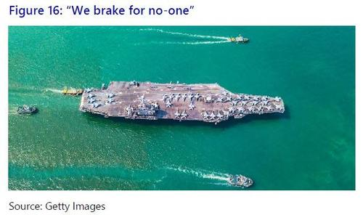
Piracy and national/imperial exclusion zones used to be maritime problems, but post-WW2, the US Navy has [with exceptions] kept the seas safe and open to trade for all carriers equally. This duty is extremely expensive, and will get more so as new ships have to be built to replace an ageing fleet. Meanwhile, China is building its own navy at breath-taking speed, and a maritime Belt and Road (BRI). As a result, a clear shift has occurred in US maritime strategy:
- 2007’s “A Co-operative Strategy for 21st Century Sea Power”, stressed: “We believe that preventing wars is as important as winning wars.”
- 2015’s update argued: “Our responsibility to the American people dictates an efficient use of our fiscal resources.”
- 2020’s title was changed to “Advantage at Sea: Prevailing with Integrated All-Domain Naval Power”, and stressed: “...the rules-based international order is once again under assault. We must prepare as a unified Naval Service to ensure that we are equal to the challenge.”
The US is also pressing ahead with the AUKUS defence alliance and the ‘Quad’ of Japan, India, and Australia to maintain naval superiority in the Indo-Pacific. This is generating geopolitical frictions, and fears of further escalation of maritime clashes in the region. The Quad has also agreed to key tech and supply-chain cooperation, with Australia a key part of a new green minerals strategy – a race in which China is still well ahead, and the EU lags.
Should any kind of major incident occur, shipping costs would escalate enormously, as can easily be seen in the case of US-UK shipping from 1887-1939: this leaped 1,600% during WW1, and these shipping data stopped entirely in September 1939 due to WW2.
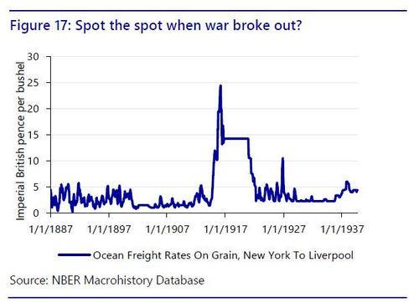
Crucially, US naval strategy is rooted in the post-WW2 power structure in which it benefitted from such control commercially. That architecture is crumbling - and there is a matching US consensus to shift towards “America First”, or “Made in America”. The thought progression from here is surely: “Why are we paying to protect shipping from China, or economies that do not support us against China?”
In short, the strategic and financial logic is: surrender control of the seas, or ensure commercial gains from it.
There are enormous implications for shipping if such a shift in thinking were to occur - and such discussions are already taking place. July 2020’s “Hidden Harbours: China’s State-backed Shipping Industry” from the Center for Strategic and International Studies argued:
“The time is long overdue for the US to reinvigorate its maritime industries and challenge the Chinese in the same game by using the very same techniques the Chinese have used to gain dominance in the global maritime industry.
The private-sector maritime industry cannot do this alone—the US maritime industry simply cannot compete against the power of the Chinese state.
The US and allied governments must bring to bear substantial and sustained political action, policies, and financial support. To do anything less is to cede control of the world’s maritime industry and global supply chains to China, and perhaps to force the US and its allies to enter their own ‘century of shame.’”
Meanwhile, stories link ports and shipping to national security (see here and here), underlining logistics are no longer seen as purely commercial areas, but rather fall within the “grey zone” between war and peace – as was the case pre-WW2. This again has major implications for the shipping business.
Expect that trend to continue ahead if the maritime past as guide, as we shall now explore.

Excerpted From: https://www.bloomberg.com/news/articles/2021-10-07/tsmc-leads-pushback-in-taiwan-against-biden-s-chip-data-bid
October 7, 2021, 1:50 AM EDT Updated on October 7, 2021, 4:57 AM EDT
A Biden administration effort to untangle global chip supply snarls is facing resistance from lawmakers and executives in Taiwan and South Korea, complicating attempts to resolve the bottlenecks hurting industries from automobiles to consumer electronics.
The U.S. Commerce Department late last month asked companies in the semiconductor supply chain to fill out questionnaires by Nov. 8 seeking information pertaining to the ongoing chip shortage. While the request is voluntary, Commerce Secretary Gina Raimondo has warned industry representatives that the White House might invoke the Defense Production Act or other tools to force their hands if they don’t respond.

